**Shoulder Joint Labeling Activity**

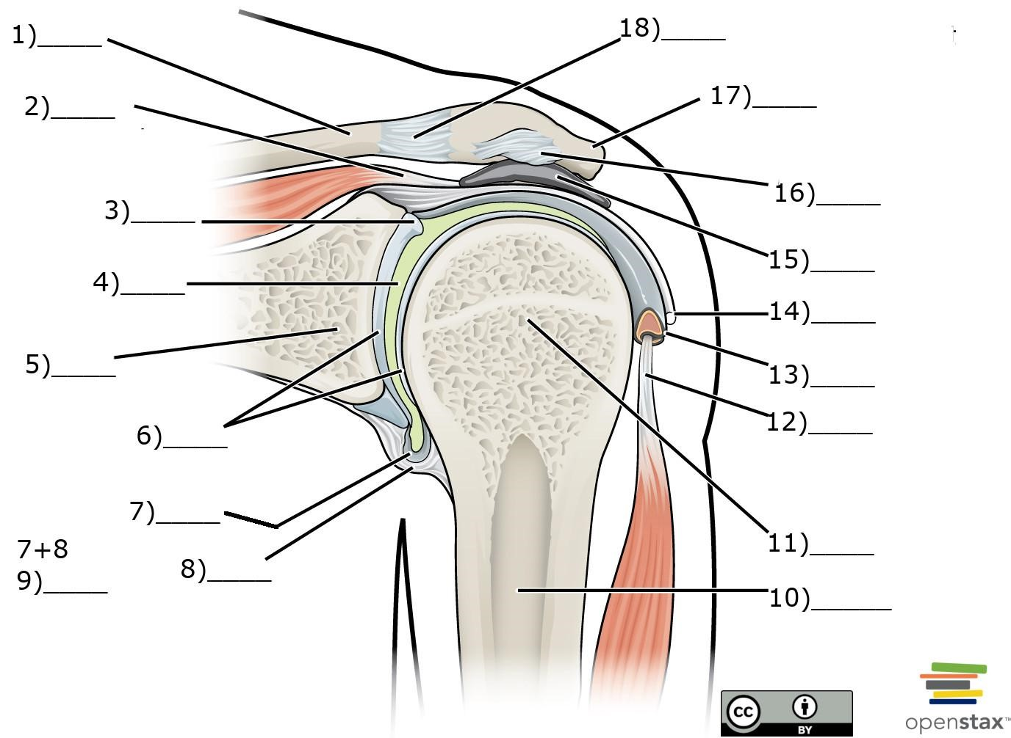

# Word Bank

1. Humerus
2. Glenoid labrum
3. Scapula
4. Subacromial bursa
5. Glenoid cavity
6. Synovial membrane
7. Articular cartilage
8. Tendon of biceps brachii muscle (long head)
9. Fibrous membrane
10. coracoacromial ligament
11. Tendon sheath
12. Tendon of supraspinatus muscle
13. Clavicle
14. Acromioclavicular ligament
15. Head of humerus
16. Articular capsule
17. Acromion of scapula

# Answer Key

1. m) Clavicle
2. l) Tendon of supraspinatus muscle
3. b) Glenoid labrum
4. e) Glenoid cavity
5. c) Scapula
6. g) Articular cartilage
7. f) Synovial membrane
8. i) Fibrous membrane
9. p) Articular capsule
10. a) Humerus
11. o) Head of humerus
12. h) Tendon of biceps brachii muscle (long head)
13. k) Tendon sheath
14. p) Articular capsule
15. d) Subacromial bursa
16. j) Coracoacromial ligament
17. q) Acromion of scapula
18. n) Acromioclavicular ligament